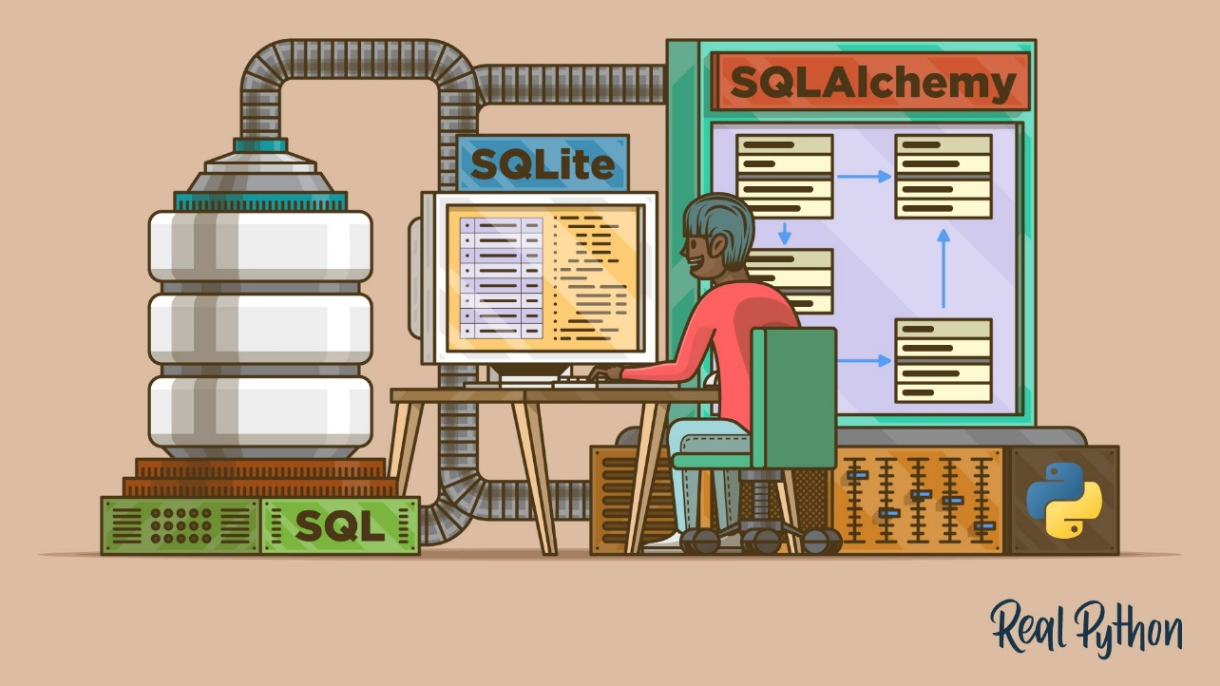

Data Management With Python, SQLite, and SQLAlchemy
by Doug Farrell Oct 14, 2020 0 Comments databases intermediate web-dev
Tweet Share Email
Table of Contents
- Using Flat Files for Data Storage
  - Advantages of Flat Files
  - Disadvantages of Flat Files
  - Flat File Example
- Using SQLite to Persist Data
  - Creating a Database Structure
  - Interacting With a Database With SQL
- Structuring a Database With SQL
  - Creating Tables With SQL
  - Maintaining a Database With SQL
- Building Relationships
  - One-to-Many Relationships
  - Many-to-Many Relationships
  - Entity Relationship Diagrams
- Working With SQLAlchemy and Python Objects
  - The Model
  - Table Creates Associations
  - ForeignKey Creates a Connection
  - relationship() Establishes a Collection
  - backref Mirrors Attributes
  - Queries Answer Questions
  - Example Program
- Providing Access to Multiple Users
- Using Flask With Python, SQLite, and SQLAlchemy
- Creating a REST API Server
- Conclusion
- Further Reading

All programs process data in one form or another, and many need to be able to save and retrieve that data from one invocation to the next. Python, SQLite, and SQLAlchemy give your programs database functionality, allowing you to store data in a single file without the need for a database server.
You can achieve similar results using flat files in any number of formats, including CSV, JSON, XML, and even custom formats. Flat files are often human-readable text files—though they can also be binary data—with a structure that can be parsed by a computer program. Below, you’ll explore using SQL databases and flat files for data storage and manipulation and learn how to decide which approach is right for your program.
In this tutorial, you’ll learn how to use:
- Flat files for data storage
- SQL to improve access to persistent data
- SQLite for data storage
- SQLAlchemy to work with data as Python objects
You can get all of the code and data you’ll see in this tutorial by clicking on the link below:
Download the sample code: Click here to get the code you’ll use to learn about data management with SQLite and SQLAlchemy in this tutorial.

Using Flat Files for Data Storage
A flat file is a file containing data with no internal hierarchy and usually no references to external files. Flat files contain human-readable characters and are very useful for creating and reading data. Because they don’t have to use fixed field widths, flat files often use other structures to make it possible for a program to parse text.
For example, comma-separated value (CSV) files are lines of plain text in which the comma character separates the data elements. Each line of text represents a row of data, and each comma-separated value is a field within that row. The comma character delimiter indicates the boundary between data values.
Python excels at reading from and saving to files. Being able to read data files with Python allows you to restore an application to a useful state when you rerun it at a later time. Being able to save data in a file allows you to share information from the program between users and sites where the application runs.
Before a program can read a data file, it has to be able to understand the data. Usually, this means the data file needs to have some structure that the application can use to read and parse the text in the file.
Below is a CSV file named author_book_publisher.csv, used by the first example program in this tutorial:
first_name,last_name,title,publisher
Isaac,Asimov,Foundation,Random House
Pearl,Buck,The Good Earth,Random House
Pearl,Buck,The Good Earth,Simon & Schuster
Tom,Clancy,The Hunt For Red October,Berkley
Tom,Clancy,Patriot Games,Simon & Schuster
Stephen,King,It,Random House
Stephen,King,It,Penguin Random House
Stephen,King,Dead Zone,Random House
Stephen,King,The Shining,Penguin Random House
John,Le Carre,"Tinker, Tailor, Soldier, Spy: A George Smiley Novel",Berkley
Alex,Michaelides,The Silent Patient,Simon & Schuster
Carol,Shaben,Into The Abyss,Simon & Schuster
The first line provides a comma-separated list of fields, which are the column names for the data that follows in the remaining lines. The rest of the lines contain the data, with each line representing a single record.
Note: Though the authors, books, and publishers are all real, the relationships between books and publishers are fictional and were created for the purposes of this tutorial.
Next, you’ll take a look at some of the advantages and disadvantages of using flat files like the above CSV to work with your data.

Advantages of Flat Files
Working with data in flat files is manageable and straightforward to implement. Having the data in a human-readable format is helpful not only for creating the data file with a text editor but also for examining the data and looking for any inconsistencies or problems.
Many applications can export flat-file versions of the data generated by the file. For example, Excel can import or export a CSV file to and from a spreadsheet. Flat files also have the advantage of being self-contained and transferable if you want to share the data.
Almost every programming language has tools and libraries that make working with CSV files easier. Python has the built-in csv module and the powerful pandas module available, making working with CSV files a potent solution.

Disadvantages of Flat Files
The advantages of working with flat files start to diminish as the data becomes larger. Large files are still human-readable, but editing them to create data or look for problems becomes a more difficult task. If your application will change the data in the file, then one solution would be to read the entire file into memory, make the changes, and write the data out to another file.
Another problem with using flat files is that you’ll need to explicitly create and maintain any relationships between parts of your data and the application program within the file syntax. Additionally, you’ll need to generate code in your application to use those relationships.
A final complication is that people you want to share your data file with will also need to know about and act on the structures and relationships you’ve created in the data. To access the information, those users will need to understand not only the structure of the data but also the programming tools necessary for accessing it.

Flat File Example
The example program examples/example_1/main.py uses the author_book_publisher.csv file to get the data and relationships in it. This CSV file maintains a list of authors, the books they’ve published, and the publishers for each of the books.
Note: The data files used in the examples are available in the project/data directory. There’s also a program file in the project/build_data directory that generates the data. That application is useful if you change the data and want to get back to a known state.
To get access to the data files used in this section and throughout the tutorial, click on the link below:
Download the sample code: Click here to get the code you’ll use to learn about data management with SQLite and SQLAlchemy in this tutorial.
The CSV file presented above is a pretty small data file containing only a few authors, books, and publishers. You should also notice some things about the data:
- The authors Stephen King and Tom Clancy appear more than once because multiple books they’ve published are represented in the data.
- The authors Stephen King and Pearl Buck have the same book published by more than one publisher.
These duplicated data fields create relationships between other parts of the data. One author can write many books, and one publisher can work with multiple authors. Authors and publishers share relationships with individual books.
The relationships in the author_book_publisher.csv file are represented by fields that appear multiple times in different rows of the data file. Because of this data redundancy, the data represents more than a single two-dimensional table. You’ll see more of this when you use the file to create an SQLite database file.
The example program examples/example_1/main.py uses the relationships embedded in the author_book_publisher.csv file to generate some data. It first presents a list of the authors and the number of books each has written. It then shows a list of publishers and the number of authors for which each has published books.
It also uses the treelib module to display a tree hierarchy of the authors, books , and publishers.
Lastly, it adds a new book to the data and redisplays the tree hierarchy with the new book in place. Here’s the main() entry-point function for this program:
1def main():
2 """The main entry point of the program"""
3 # Get the resources for the program
4 with resources.path(
5 "project.data", "author_book_publisher.csv"
6 ) as filepath:
7 data = get_data(filepath)
8
9 # Get the number of books printed by each publisher
10 books_by_publisher = get_books_by_publisher(data, ascending=False)
11 for publisher, total_books in books_by_publisher.items():
12 print(f"Publisher: {publisher}, total books: {total_books}")
13 print()
14
15 # Get the number of authors each publisher publishes
16 authors_by_publisher = get_authors_by_publisher(data, ascending=False)
17 for publisher, total_authors in authors_by_publisher.items():
18 print(f"Publisher: {publisher}, total authors: {total_authors}")
19 print()
20
21 # Output hierarchical authors data
22 output_author_hierarchy(data)
23
24 # Add a new book to the data structure
25 data = add_new_book(
26 data,
27 author_name="Stephen King",
28 book_title="The Stand",
29 publisher_name="Random House",
30 )
31
32 # Output the updated hierarchical authors data
33 output_author_hierarchy(data)
The Python code above takes the following steps:
- Lines 4 to 7 read the author_book_publisher.csv file into a pandas DataFrame.
- Lines 10 to 13 print the number of books published by each publisher.
- Lines 16 to 19 print the number of authors associated with each publisher.
- Line 22 outputs the book data as a hierarchy sorted by authors.
- Lines 25 to 30 add a new book to the in-memory structure.
- Line 33 outputs the book data as a hierarchy sorted by authors, including the newly added book.
Running this program generates the following output:
$ python main.py
Publisher: Simon & Schuster, total books: 4
Publisher: Random House, total books: 4
Publisher: Penguin Random House, total books: 2
Publisher: Berkley, total books: 2

Publisher: Simon & Schuster, total authors: 4
Publisher: Random House, total authors: 3
Publisher: Berkley, total authors: 2
Publisher: Penguin Random House, total authors: 1

Authors
├── Alex Michaelides
│ └── The Silent Patient
│ └── Simon & Schuster
├── Carol Shaben
│ └── Into The Abyss
│ └── Simon & Schuster
├── Isaac Asimov
│ └── Foundation
│ └── Random House
├── John Le Carre
│ └── Tinker, Tailor, Soldier, Spy: A George Smiley Novel
│ └── Berkley
├── Pearl Buck
│ └── The Good Earth
│ ├── Random House
│ └── Simon & Schuster
├── Stephen King
│ ├── Dead Zone
│ │ └── Random House
│ ├── It
│ │ ├── Penguin Random House
│ │ └── Random House
│ └── The Shining
│ └── Penguin Random House
└── Tom Clancy
├── Patriot Games
│ └── Simon & Schuster
└── The Hunt For Red October
└── Berkley
The author hierarchy above is presented twice in the output, with the addition of Stephen King’s The Stand, published by Random House. The actual output above has been edited and shows only the first hierarchy output to save space.
main() calls other functions to perform the bulk of the work. The first function it calls is get_data():
def get_data(filepath):
"""Get book data from the csv file"""
return pd.read_csv(filepath)
This function takes in the file path to the CSV file and uses pandas to read it into a pandas DataFrame, which it then passes back to the caller. The return value of this function becomes the data structure passed to the other functions that make up the program.
get_books_by_publisher() calculates the number of books published by each publisher. The resulting pandas Series uses the pandas GroupBy functionality to group by publisher and then sort based on the ascending flag:
def get_books_by_publisher(data, ascending=True):
"""Return the number of books by each publisher as a pandas series"""
return data.groupby("publisher").size().sort_values(ascending=ascending)
get_authors_by_publisher() does essentially the same thing as the previous function, but for authors:
def get_authors_by_publisher(data, ascending=True):
"""Returns the number of authors by each publisher as a pandas series"""
return (
data.assign(name=data.first_name.str.cat(data.last_name, sep=" "))
.groupby("publisher")
.nunique()
.loc[:, "name"]
.sort_values(ascending=ascending)
)
add_new_book() creates a new book in the pandas DataFrame. The code checks to see if the author, book, or publisher already exists. If not, then it creates a new book and appends it to the pandas DataFrame:
def add_new_book(data, author_name, book_title, publisher_name):
"""Adds a new book to the system"""
# Does the book exist?
first_name, _, last_name = author_name.partition(" ")
if any(
(data.first_name == first_name)
& (data.last_name == last_name)
& (data.title == book_title)
& (data.publisher == publisher_name)
):
return data
# Add the new book
return data.append(
{
"first_name": first_name,
"last_name": last_name,
"title": book_title,
"publisher": publisher_name,
},
ignore_index=True,
)
output_author_hierarchy() uses nested for loops to iterate through the levels of the data structure. It then uses the treelib module to output a hierarchical listing of the authors, the books they’ve published, and the publishers who’ve published those books:
def output_author_hierarchy(data):
"""Output the data as a hierarchy list of authors"""
authors = data.assign(
name=data.first_name.str.cat(data.last_name, sep=" ")
)
authors_tree = Tree()
authors_tree.create_node("Authors", "authors")
for author, books in authors.groupby("name"):
authors_tree.create_node(author, author, parent="authors")
for book, publishers in books.groupby("title")["publisher"]:
book_id = f"{author}:{book}"
authors_tree.create_node(book, book_id, parent=author)
for publisher in publishers:
authors_tree.create_node(publisher, parent=book_id)

# Output the hierarchical authors data
authors_tree.show()
This application works well and illustrates the power available to you with the pandas module. The module provides excellent functionality for reading a CSV file and interacting with the data.
Let’s push on and create an identically functioning program using Python, an SQLite database version of the author and publication data, and SQLAlchemy to interact with that data.

Using SQLite to Persist Data
As you saw earlier, there’s redundant data in the author_book_publisher.csv file. For example, all information about Pearl Buck’s The Good Earth is listed twice because two different publishers have published the book.
Imagine if this data file contained more related data, like the author’s address and phone number, publication dates and ISBNs for books, or addresses, phone numbers, and perhaps yearly revenue for publishers. This data would be duplicated for each root data item, like author, book, or publisher.
It’s possible to create data this way, but it would be exceptionally unwieldy. Think about the problems keeping this data file current. What if Stephen King wanted to change his name? You’d have to update multiple records containing his name and make sure there were no typos.
Worse than the data duplication would be the complexity of adding other relationships to the data. What if you decided to add phone numbers for the authors, and they had phone numbers for home, work, mobile, and perhaps more? Every new relationship that you’d want to add for any root item would multiply the number of records by the number of items in that new relationship.
This problem is one reason that relationships exist in database systems. An important topic in database engineering is database normalization, or the process of breaking apart data to reduce redundancy and increase integrity. When a database structure is extended with new types of data, having it normalized beforehand keeps changes to the existing structure to a minimum.
The SQLite database is available in Python, and according to the SQLite home page, it’s used more than all other database systems combined. It offers a full-featured relational database management system (RDBMS) that works with a single file to maintain all the database functionality.
It also has the advantage of not requiring a separate database server to function. The database file format is cross-platform and accessible to any programming language that supports SQLite.
All of this is interesting information, but how is it relevant to the use of flat files for data storage? You’ll find out below!

Creating a Database Structure
The brute force approach to getting the author_book_publisher.csv data into an SQLite database would be to create a single table matching the structure of the CSV file. Doing this would ignore a good deal of SQLite’s power.
Relational databases provide a way to store structured data in tables and establish relationships between those tables. They usually use Structured Query Language (SQL) as the primary way to interact with the data. This is an oversimplification of what RDBMSs provide, but it’s sufficient for the purposes of this tutorial.
An SQLite database provides support for interacting with the data table using SQL. Not only does an SQLite database file contain the data, but it also has a standardized way to interact with the data. This support is embedded in the file, meaning that any programming language that can use an SQLite file can also use SQL to work with it.

Interacting With a Database With SQL
SQL is a declarative language used to create, manage, and query the data contained in a database. A declarative language describes what is to be accomplished rather than how it should be accomplished. You’ll see examples of SQL statements later when you get to creating database tables.

Structuring a Database With SQL
To take advantage of the power in SQL, you’ll need to apply some database normalization to the data in the author_book_publisher.csv file. To do this, you’ll separate the authors, books, and publishers into separate database tables.
Conceptually, data is stored in the database in two-dimensional table structures. Each table consists of rows of records, and each record consists of columns, or fields, containing data.
The data contained in the fields is of pre-defined types, including text, integers, floats, and more. CSV files are different because all the fields are text and must be parsed by a program to have a data type assigned to them.
Each record in the table has a primary key defined to give a record a unique identifier. The primary key is similar to the key in a Python dictionary. The database engine itself often generates the primary key as an incrementing integer value for every record inserted into the database table.
Though the primary key is often automatically generated by the database engine, it doesn’t have to be. If the data stored in a field is unique across all other data in the table in that field, then it can be the primary key. For example, a table containing data about books could use the book’s ISBN as the primary key.

Creating Tables With SQL
Here’s how you can create the three tables representing the authors, books, and publishers in the CSV file using SQL statements:
CREATE TABLE author (
author_id INTEGER NOT NULL PRIMARY KEY,
first_name VARCHAR,
last_name VARCHAR
);

CREATE TABLE book (
book_id INTEGER NOT NULL PRIMARY KEY,
author_id INTEGER REFERENCES author,
title VARCHAR
);

CREATE TABLE publisher (
publisher_id INTEGER NOT NULL PRIMARY KEY,
name VARCHAR
);
Notice there are no file operations, no variables created, and no structures to hold them. The statements describe only the desired result: the creation of a table with particular attributes. The database engine determines how to do this.
Once you’ve created and populated this table with author data from the author_book_publisher.csv file, you can access it using SQL statements. The following statement (also called a query) uses the wildcard character (*) to get all the data in the author table and output it:
SELECT * FROM author;
You can use the sqlite3 command-line tool to interact with the author_book_publisher.db database file in the project/data directory:
$ sqlite3 author_book_publisher.db
Once the SQLite command-line tool is running with the database open, you can enter SQL commands. Here’s the above SQL command and its output, followed by the .q command to exit the program:
sqlite> SELECT * FROM author;
1|Isaac|Asimov
2|Pearl|Buck
3|Tom|Clancy
4|Stephen|King
5|John|Le Carre
6|Alex|Michaelides
7|Carol|Shaben

sqlite> .q
Notice that each author exists only once in the table. Unlike the CSV file, which had multiple entries for some of the authors, here, only one unique record per author is necessary.

Maintaining a Database With SQL
SQL provides ways to work with existing databases and tables by inserting new data and updating or deleting existing data. Here’s an example SQL statement for inserting a new author into the author table:
INSERT INTO author
(first_name, last_name)
VALUES ('Paul', 'Mendez');
This SQL statement inserts the values ‘Paul‘ and ‘Mendez‘ into the respective columns first_name and last_name of the author table.
Notice that the author_id column isn’t specified. Because that column is the primary key, the database engine generates the value and inserts it as part of the statement execution.
Updating records in a database table is an uncomplicated process. For instance, suppose Stephen King wanted to be known by his pen name, Richard Bachman. Here’s an the SQL statement to update the database record:
UPDATE author
SET first_name = 'Richard', last_name = 'Bachman'
WHERE first_name = 'Stephen' AND last_name = 'King';
The SQL statement locates the single record for 'Stephen King' using the conditional statement WHERE first_name = 'Stephen' AND last_name = 'King' and then updates the first_name and last_name fields with the new values. SQL uses the equals sign (=) as both the comparison operator and assignment operator.
You can also delete records from a database. Here’s an example SQL statement to delete a record from the author table:
DELETE FROM author
WHERE first_name = 'Paul'
AND last_name = 'Mendez';
This SQL statement deletes a single row from the author table where the first_name is equal to 'Paul' and the last_name is equal to 'Mendez'.
Be careful when deleting records! The conditions you set must be as specific as possible. A conditional that’s too broad can lead to deleting more records than you intend. For example, if the condition were based only on the line first_name = 'Paul', then all authors with a first name of Paul would be deleted from the database.
Note: To avoid the accidental deletion of records, many applications don’t allow deletions at all. Instead, the record has another column to indicate if it’s in use or not. This column might be named active and contain a value that evaluates to either True or False, indicating whether the record should be included when querying the database.
For example, the SQL query below would get all columns for all active records in some_table:
SELECT
*
FROM some_table
WHERE active = 1;
SQLite doesn’t have a Boolean data type, so the active column is represented by an integer with a value of 0 or 1 to indicate the state of the record. Other database systems may or may not have native Boolean data types.
It’s entirely possible to build database applications in Python using SQL statements directly in the code. Doing so returns data to the application as a list of lists or list of dictionaries.
Using raw SQL is a perfectly acceptable way to work with the data returned by queries to the database. However, rather than doing that, you’re going to move directly into using SQLAlchemy to work with databases.

Building Relationships
Another feature of database systems that you might find even more powerful and useful than data persistence and retrieval is relationships. Databases that support relationships allow you to break up data into multiple tables and establish connections between them.
The data in the author_book_publisher.csv file represents the data and relationships by duplicating data. A database handles this by breaking the data up into three tables—author, book, and publisher—and establishing relationships between them.
After getting all the data you want into one place in the CSV file, why would you want to break it up into multiple tables? Wouldn’t it be more work to create and put back together again? That’s true to an extent, but the advantages of breaking up the data and putting it back together using SQL could win you over!

One-to-Many Relationships
A one-to-many relationship is like that of a customer ordering items online. One customer can have many orders, but each order belongs to one customer. The author_book_publisher.db database has a one-to-many relationship in the form of authors and books. Each author can write many books, but each book is written by one author.
As you saw in the table creation above, the implementation of these separate entities is to place each into a database table, one for authors and one for books. But how does the one-to-many relationship between these two tables get implemented?
Remember, each table in a database has a field designated as the primary key for that table. Each table above has a primary key field named using this pattern: <table name>_id.
The book table shown above contains a field, author_id, that references the author table. The author_id field establishes a one-to-many relationship between authors and books that looks like this:
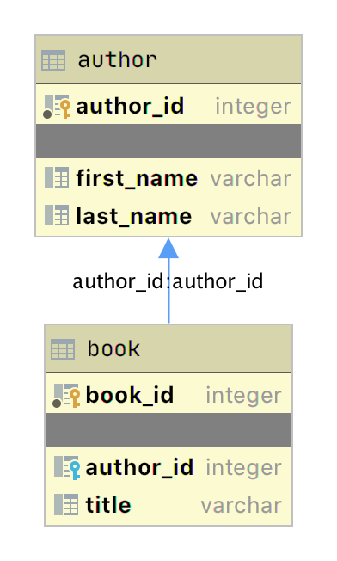
The diagram above is a simple entity-relationship diagram (ERD) created with the JetBrains DataGrip application showing the tables author and book as boxes with their respective primary key and data fields. Two graphical items add information about the relationship:
- The small yellow and blue key icons indicate the primary and foreign keys for the table, respectively.
- The arrow connecting book to author indicates the relationship between the tables based on the author_id foreign key in the book table.
When you add a new book to the book table, the data includes an author_id value for an existing author in the author table. In this way, all the books written by an author have a lookup relationship back to that unique author.
Now that you have separate tables for authors and books, how do you use the relationship between them? SQL supports what’s called a JOIN operation, which you can use to tell the database how to connect two or more tables.
The SQL query below joins the author and book table together using the SQLite command-line application:
sqlite> SELECT
...> a.first_name || ' ' || a.last_name AS author_name,
...> b.title AS book_title
...> FROM author a
...> JOIN book b ON b.author_id = a.author_id
...> ORDER BY a.last_name ASC;
Isaac Asimov|Foundation
Pearl Buck|The Good Earth
Tom Clancy|The Hunt For Red October
Tom Clancy|Patriot Games
Stephen King|It
Stephen King|Dead Zone
Stephen King|The Shining
John Le Carre|Tinker, Tailor, Soldier, Spy: A George Smiley Novel
Alex Michaelides|The Silent Patient
Carol Shaben|Into The Abyss
The SQL query above gathers information from both the author and book table by joining the tables using the relationship established between the two. SQL string concatenation assigns the author’s full name to the alias author_name. The data gathered by the query are sorted in ascending order by the last_name field.
There are a few things to notice in the SQL statement. First, authors are presented by their full names in a single column and sorted by their last names. Also, authors appear in the output multiple times because of the one-to-many relationship. An author’s name is duplicated for each book they’ve written in the database.
By creating separate tables for authors and books and establishing the relationship between them, you’ve reduced redundancy in the data. Now you only have to edit an author’s data in one place, and that change appears in any SQL query accessing the data.

Many-to-Many Relationships
Many-to-many relationships exist in the author_book_publisher.db database between authors and publishers as well as between books and publishers. One author can work with many publishers, and one publisher can work with many authors. Similarly, one book can be published by many publishers, and one publisher can publish many books.
Handling this situation in the database is more involved than a one-to-many relationship because the relationship goes both ways. Many-to-many relationships are created by an association table acting as a bridge between the two related tables.
The association table contains at least two foreign key fields, which are the primary keys of each of the two associated tables. This SQL statement creates the association table relating the author and publisher tables:
CREATE TABLE author_publisher (
author_id INTEGER REFERENCES author,
publisher_id INTEGER REFERENCES publisher
);
The SQL statements create a new author_publisher table referencing the primary keys of the existing author and publisher tables. The author_publisher table is an association table establishing relationships between an author and a publisher.
Because the relationship is between two primary keys, there’s no need to create a primary key for the association table itself. The combination of the two related keys creates a unique identifier for a row of data.
As before, you use the JOIN keyword to connect two tables together. Connecting the author table to the publisher table is a two-step process:
- JOIN the author table with the author_publisher table.
- JOIN the author_publisher table with the publisher table.
The author_publisher association table provides the bridge through which the JOIN connects the two tables. Here’s an example SQL query returning a list of authors and the publishers publishing their books:
1sqlite> SELECT
2 ...> a.first_name || ' ' || a.last_name AS author_name,
3 ...> p.name AS publisher_name
4 ...> FROM author a
5 ...> JOIN author_publisher ap ON ap.author_id = a.author_id
6 ...> JOIN publisher p ON p.publisher_id = ap.publisher_id
7 ...> ORDER BY a.last_name ASC;
8Isaac Asimov|Random House
9Pearl Buck|Random House
10Pearl Buck|Simon & Schuster
11Tom Clancy|Berkley
12Tom Clancy|Simon & Schuster
13Stephen King|Random House
14Stephen King|Penguin Random House
15John Le Carre|Berkley
16Alex Michaelides|Simon & Schuster
17Carol Shaben|Simon & Schuster
The statements above perform the following actions:
- Line 1 starts a SELECT statement to get data from the database.
- Line 2 selects the first and last name from the author table using the a alias for the author table and concatenates them together with a space character.
- Line 3 selects the publisher’s name aliased to publisher_name.
- Line 4 uses the author table as the first source from which to retrieve data and assigns it to the alias a.
- Line 5 is the first step of the process outlined above for connecting the author table to the publisher table. It uses the alias ap for the author_publisher association table and performs a JOIN operation to connect the ap.author_id foreign key reference to the a.author_id primary key in the author table.
- Line 6 is the second step in the two-step process mentioned above. It uses the alias p for the publisher table and performs a JOIN operation to relate the ap.publisher_id foreign key reference to the p.publisher_id primary key in the publisher table.
- Line 7 sorts the data by the author’s last name in ascending alphabetical order and ends the SQL query.
- Lines 8 to 17 are the output of the SQL query.
Note that the data in the source author and publisher tables are normalized, with no data duplication. Yet the returned results have duplicated data where necessary to answer the SQL query.
The SQL query above demonstrates how to make use of a relationship using the SQL JOIN keyword, but the resulting data is a partial re-creation of the author_book_publisher.csv CSV data. What’s the win for having done the work of creating a database to separate the data?
Here’s another SQL query to show a little bit of the power of SQL and the database engine:
1sqlite> SELECT
2 ...> a.first_name || ' ' || a.last_name AS author_name,
3 ...> COUNT(b.title) AS total_books
4 ...> FROM author a
5 ...> JOIN book b ON b.author_id = a.author_id
6 ...> GROUP BY author_name
7 ...> ORDER BY total_books DESC, a.last_name ASC;
8Stephen King|3
9Tom Clancy|2
10Isaac Asimov|1
11Pearl Buck|1
12John Le Carre|1
13Alex Michaelides|1
14Carol Shaben|1
The SQL query above returns the list of authors and the number of books they’ve written. The list is sorted first by the number of books in descending order, then by the author’s name in alphabetical order:
- Line 1 begins the SQL query with the SELECT keyword.
- Line 2 selects the author’s first and last names, separated by a space character, and creates the alias author_name.
- Line 3 counts the number of books written by each author, which will be used later by the ORDER BY clause to sort the list.
- Line 4 selects the author table to get data from and creates the a alias.
- Line 5 connects to the related book table through a JOIN to the author_id and creates the b alias for the book table.
- Line 6 generates the aggregated author and total number of books data by using the GROUP BY keyword. GROUP BY is what groups each author_name and controls what books are tallied by COUNT() for that author.
- Line 7 sorts the output first by number of books in descending order, then by the author’s last name in ascending alphabetical order.
- Lines 8 to 14 are the output of the SQL query.
In the above example, you take advantage of SQL to perform aggregation calculations and sort the results into a useful order. Having the database perform calculations based on its built-in data organization ability is usually faster than performing the same kinds of calculations on raw data sets in Python. SQL offers the advantages of using set theory embedded in RDBMS databases.

Entity Relationship Diagrams
An entity-relationship diagram (ERD) is a visual depiction of an entity-relationship model for a database or part of a database. The author_book_publisher.db SQLite database is small enough that the entire database can be visualized by the diagram shown below:
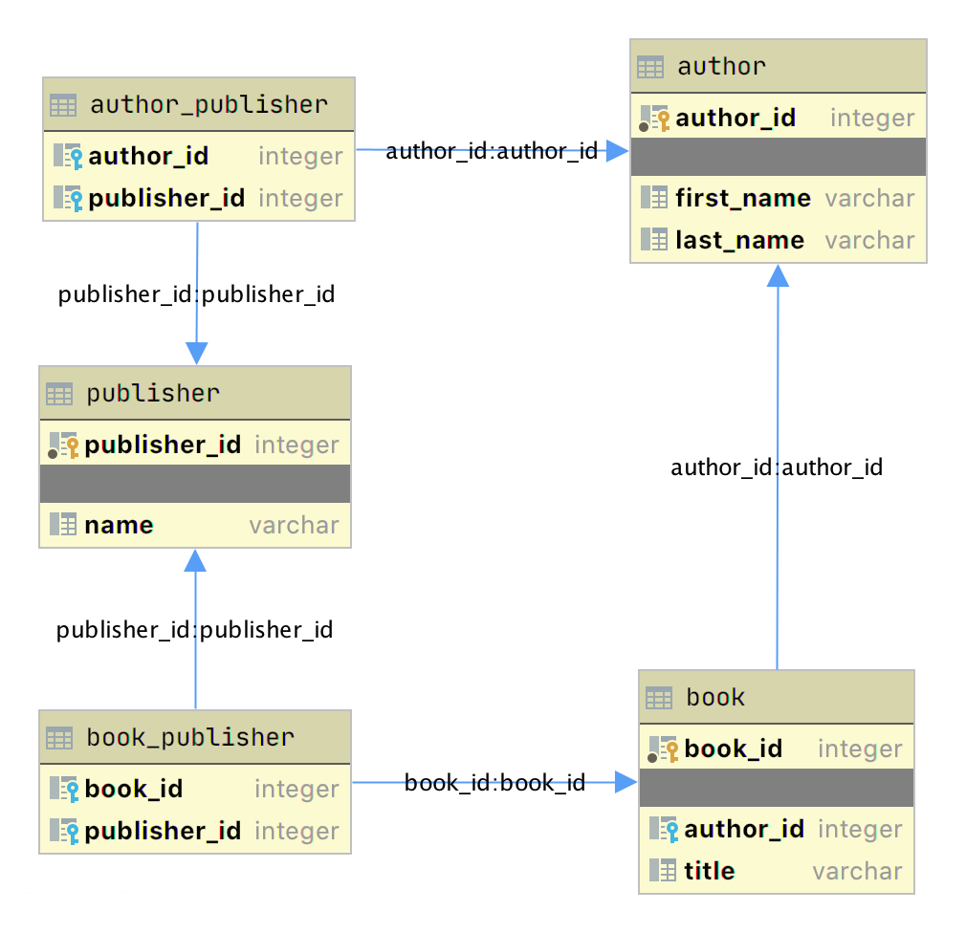
This diagram presents the table structures in the database and the relationships between them. Each box represents a table and contains the fields defined in the table, with the primary key indicated first if it exists.
The arrows show the relationships between the tables connecting a foreign key field in one table to a field, often the primary key, in another table. The table book_publisher has two arrows, one connecting it to the book table and another connecting it to the publisher table. The arrow indicates the many-to-many relationship between the book and publisher tables. The author_publisher table provides the same relationship between author and publisher.

Working With SQLAlchemy and Python Objects
SQLAlchemy is a powerful database access tool kit for Python, with its object-relational mapper (ORM) being one of its most famous components, and the one discussed and used here.
When you’re working in an object-oriented language like Python, it’s often useful to think in terms of objects. It’s possible to map the results returned by SQL queries to objects, but doing so works against the grain of how the database works. Sticking with the scalar results provided by SQL works against the grain of how Python developers work. This problem is known as object-relational impedance mismatch.
The ORM provided by SQLAlchemy sits between the SQLite database and your Python program and transforms the data flow between the database engine and Python objects. SQLAlchemy allows you to think in terms of objects and still retain the powerful features of a database engine.

The Model
One of the fundamental elements to enable connecting SQLAlchemy to a database is creating a model. The model is a Python class defining the data mapping between the Python objects returned as a result of a database query and the underlying database tables.
The entity-relationship diagram displayed earlier shows boxes connected with arrows. The boxes are the tables built with the SQL commands and are what the Python classes will model. The arrows are the relationships between the tables.
The models are Python classes inheriting from an SQLAlchemy Base class. The Base class provides the interface operations between instances of the model and the database table.
Below is the models.py file that creates the models to represent the author_book_publisher.db database:
1from sqlalchemy import Column, Integer, String, ForeignKey, Table
2from sqlalchemy.orm import relationship, backref
3from sqlalchemy.ext.declarative import declarative_base
4
5Base = declarative_base()
6
7author_publisher = Table(
8 "author_publisher",
9 Base.metadata,
10 Column("author_id", Integer, ForeignKey("author.author_id")),
11 Column("publisher_id", Integer, ForeignKey("publisher.publisher_id")),
12)
13
14book_publisher = Table(
15 "book_publisher",
16 Base.metadata,
17 Column("book_id", Integer, ForeignKey("book.book_id")),
18 Column("publisher_id", Integer, ForeignKey("publisher.publisher_id")),
19)
20
21class Author(Base):
22 __tablename__ = "author"
23 author_id = Column(Integer, primary_key=True)
24 first_name = Column(String)
25 last_name = Column(String)
26 books = relationship("Book", backref=backref("author"))
27 publishers = relationship(
28 "Publisher", secondary=author_publisher, back_populates="authors"
29 )
30
31class Book(Base):
32 __tablename__ = "book"
33 book_id = Column(Integer, primary_key=True)
34 author_id = Column(Integer, ForeignKey("author.author_id"))
35 title = Column(String)
36 publishers = relationship(
37 "Publisher", secondary=book_publisher, back_populates="books"
38 )
39
40class Publisher(Base):
41 __tablename__ = "publisher"
42 publisher_id = Column(Integer, primary_key=True)
43 name = Column(String)
44 authors = relationship(
45 "Author", secondary=author_publisher, back_populates="publishers"
46 )
47 books = relationship(
48 "Book", secondary=book_publisher, back_populates="publishers"
49 )
Here’s what’s going on in this module:
- Line 1 imports the Column, Integer, String, ForeignKey, and Table classes from SQLAlchemy, which are used to help define the model attributes.
- Line 2 imports the relationship() and backref objects, which are used to create the relationships between objects.
- Line 3 imports the declarative_base object, which connects the database engine to the SQLAlchemy functionality of the models.
- Line 5 creates the Base class, which is what all models inherit from and how they get SQLAlchemy ORM functionality.
- Lines 7 to 12 create the author_publisher association table model.
- Lines 14 to 19 create the book_publisher association table model.
- Lines 21 to 29 define the Author class model to the author database table.
- Lines 31 to 38 define the Book class model to the book database table.
- Lines 40 to 49 define the Publisher class model to the publisher database table.
The description above shows the mapping of the five tables in the author_book_publisher.db database. But it glosses over some SQLAlchemy ORM features, including Table, ForeignKey, relationship(), and backref. Let’s get into those now.

Table Creates Associations
author_publisher and book_publisher are both instances of the Table class that create the many-to-many association tables used between the author and publisher tables and the book and publisher tables, respectively.
The SQLAlchemy Table class creates a unique instance of an ORM mapped table within the database. The first parameter is the table name as defined in the database, and the second is Base.metadata, which provides the connection between the SQLAlchemy functionality and the database engine.
The rest of the parameters are instances of the Column class defining the table fields by name, their type, and in the example above, an instance of a ForeignKey.

ForeignKey Creates a Connection
The SQLAlchemy ForeignKey class defines a dependency between two Column fields in different tables. A ForeignKey is how you make SQLAlchemy aware of the relationships between tables. For example, this line from the author_publisher instance creation establishes a foreign key relationship:
Column("author_id", Integer, ForeignKey("author.author_id"))
The statement above tells SQLAlchemy that there’s a column in the author_publisher table named author_id. The type of that column is Integer, and author_id is a foreign key related to the primary key in the author table.
Having both author_id and publisher_id defined in the author_publisher Table instance creates the connection from the author table to the publisher table and vice versa, establishing a many-to-many relationship.

relationship() Establishes a Collection
Having a ForeignKey defines the existence of the relationship between tables but not the collection of books an author can have. Take a look at this line in the Author class definition:
books = relationship("Book", backref=backref("author"))
The code above defines a parent-child collection. The books attribute being plural (which is not a requirement, just a convention) is an indication that it’s a collection.
The first parameter to relationship(), the class name Book (which is not the table name book), is the class to which the books attribute is related. The relationship informs SQLAlchemy that there’s a relationship between the Author and Book classes. SQLAlchemy will find the relationship in the Book class definition:
author_id = Column(Integer, ForeignKey("author.author_id"))
SQLAlchemy recognizes that this is the ForeignKey connection point between the two classes. You’ll get to the backref parameter in relationship() in a moment.
The other relationship in Author is to the Publisher class. This is created with the following statement in the Author class definition:
publishers = relationship(
"Publisher", secondary=author_publisher, back_populates="authors"
)
Like books, the attribute publishers indicates a collection of publishers associated with an author. The first parameter, "Publisher", informs SQLAlchemy what the related class is. The second and third parameters are secondary=author_publisher and back_populates="authors":
- secondary tells SQLAlchemy that the relationship to the Publisher class is through a secondary table, which is the author_publisher association table created earlier in models.py. The secondary parameter makes SQLAlchemy find the publisher_id ForeignKey defined in the author_publisher association table.
- back_populates is a convenience configuration telling SQLAlchemy that there’s a complementary collection in the Publisher class called authors.

backref Mirrors Attributes
The backref parameter of the books collection relationship() creates an author attribute for each Book instance. This attribute refers to the parent Author that the Book instance is related to.
For example, if you executed the following Python code, then a Book instance would be returned from the SQLAlchemy query. The Book instance has attributes that can be used to print out information about the book:
book = session.query(Book).filter_by(Book.title == "The Stand").one_or_none()
print(f"Authors name: {book.author.first_name} {book.author.last_name}")
The existence of the author attribute in the Book above is because of the backref definition. A backref can be very handy to have when you need to refer to the parent and all you have is a child instance.

Queries Answer Questions
You can make a basic query like SELECT * FROM author; in SQLAlchemy like this:
results = session.query(Author).all()
The session is an SQLAlchemy object used to communicate with SQLite in the Python example programs. Here, you tell the session you want to execute a query against the Author model and return all records.
At this point, the advantages of using SQLAlchemy instead of plain SQL might not be obvious, especially considering the setup required to create the models representing the database. The results returned by the query is where the magic happens. Instead of getting back a list of lists of scalar data, you’ll get back a list of instances of Author objects with attributes matching the column names you defined.
The books and publishers collections maintained by SQLAlchemy create a hierarchical list of authors and the books they’ve written as well as the publishers who’ve published them.
Behind the scenes, SQLAlchemy turns the object and method calls into SQL statements to execute against the SQLite database engine. SQLAlchemy transforms the data returned by SQL queries into Python objects.
With SQLAlchemy, you can perform the more complex aggregation query shown earlier for the list of authors and the number of books they’ve written like this:
author_book_totals = (
session.query(
Author.first_name,
Author.last_name,
func.count(Book.title).label("book_total")
)
.join(Book)
.group_by(Author.last_name)
.order_by(desc("book_total"))
.all()
)
The query above gets the author’s first and last name, along with a count of the number of books that the author has written. The aggregating count used by the group_by clause is based on the author’s last name. Finally, the results are sorted in descending order based on the aggregated and aliased book_total.

Example Program
The example program examples/example_2/main.py has the same functionality as examples/example_1/main.py but uses SQLAlchemy exclusively to interface with the author_book_publisher.db SQLite database. The program is broken up into the main() function and the functions it calls:
1def main():
2 """Main entry point of program"""
3 # Connect to the database using SQLAlchemy
4 with resources.path(
5 "project.data", "author_book_publisher.db"
6 ) as sqlite_filepath:
7 engine = create_engine(f"sqlite:///{sqlite_filepath}")
8 Session = sessionmaker()
9 Session.configure(bind=engine)
10 session = Session()
11
12 # Get the number of books printed by each publisher
13 books_by_publisher = get_books_by_publishers(session, ascending=False)
14 for row in books_by_publisher:
15 print(f"Publisher: {row.name}, total books: {row.total_books}")
16 print()
17
18 # Get the number of authors each publisher publishes
19 authors_by_publisher = get_authors_by_publishers(session)
20 for row in authors_by_publisher:
21 print(f"Publisher: {row.name}, total authors: {row.total_authors}")
22 print()
23
24 # Output hierarchical author data
25 authors = get_authors(session)
26 output_author_hierarchy(authors)
27
28 # Add a new book
29 add_new_book(
30 session,
31 author_name="Stephen King",
32 book_title="The Stand",
33 publisher_name="Random House",
34 )
35 # Output the updated hierarchical author data
36 authors = get_authors(session)
37 output_author_hierarchy(authors)
This program is a modified version of examples/example_1/main.py. Let’s go over the differences:
- Lines 4 to 7 first initialize the sqlite_filepath variable to the database file path. Then they create the engine variable to communicate with SQLite and the author_book_publisher.db database file, which is SQLAlchemy’s access point to the database.
- Line 8 creates the Session class from the SQLAlchemy’s sessionmaker().
- Line 9 binds the Session to the engine created in line 8.
- Line 10 creates the session instance, which is used by the program to communicate with SQLAlchemy.
The rest of the function is similar, except for the replacement of data with session as the first parameter to all the functions called by main().
get_books_by_publisher() has been refactored to use SQLAlchemy and the models you defined earlier to get the data requested:
1def get_books_by_publishers(session, ascending=True):
2 """Get a list of publishers and the number of books they've published"""
3 if not isinstance(ascending, bool):
4 raise ValueError(f"Sorting value invalid: {ascending}")
5
6 direction = asc if ascending else desc
7
8 return (
9 session.query(
10 Publisher.name, func.count(Book.title).label("total_books")
11 )
12 .join(Publisher.books)
13 .group_by(Publisher.name)
14 .order_by(direction("total_books"))
15 )
Here’s what the new function, get_books_by_publishers(), is doing:
- Line 6 creates the direction variable and sets it equal to the SQLAlchemy desc or asc function depending on the value of the ascending parameter.
- Lines 9 to 11 query the Publisher table for data to return, which in this case are Publisher.name and the aggregate total of Book objects associated with an author, aliased to total_books.
- Line 12 joins to the Publisher.books collection.
- Line 13 aggregates the book counts by the Publisher.name attribute.
- Line 14 sorts the output by the book counts according to the operator defined by direction.
- Line 15 closes the object, executes the query, and returns the results to the caller.
All the above code expresses what is wanted rather than how it’s to be retrieved. Now instead of using SQL to describe what’s wanted, you’re using Python objects and methods. What’s returned is a list of Python objects instead of a list of tuples of data.
get_authors_by_publisher() has also been modified to work exclusively with SQLAlchemy. Its functionality is very similar to the previous function, so a function description is omitted:
def get_authors_by_publishers(session, ascending=True):
"""Get a list of publishers and the number of authors they've published"""
if not isinstance(ascending, bool):
raise ValueError(f"Sorting value invalid: {ascending}")

direction = asc if ascending else desc

return (
session.query(
Publisher.name,
func.count(Author.first_name).label("total_authors"),
)
.join(Publisher.authors)
.group_by(Publisher.name)
.order_by(direction("total_authors"))
)
get_authors() has been added to get a list of authors sorted by their last names. The result of this query is a list of Author objects containing a collection of books. The Author objects already contain hierarchical data, so the results don’t have to be reformatted:
def get_authors(session):
"""Get a list of author objects sorted by last name"""
return session.query(Author).order_by(Author.last_name).all()
Like its previous version, add_new_book() is relatively complex but straightforward to understand. It determines if a book with the same title, author, and publisher exists in the database already.
If the search query finds an exact match, then the function returns. If no book matches the exact search criteria, then it searches to see if the author has written a book using the passed in title. This code exists to prevent duplicate books from being created in the database.
If no matching book exists, and the author hasn’t written one with the same title, then a new book is created. The function then retrieves or creates an author and publisher. Once instances of the Book, Author and Publisher exist, the relationships between them are created, and the resulting information is saved to the database:
1def add_new_book(session, author_name, book_title, publisher_name):
2 """Adds a new book to the system"""
3 # Get the author's first and last names
4 first_name, _, last_name = author_name.partition(" ")
5
6 # Check if book exists
7 book = (
8 session.query(Book)
9 .join(Author)
10 .filter(Book.title == book_title)
11 .filter(
12 and_(
13 Author.first_name == first_name, Author.last_name == last_name
14 )
15 )
16 .filter(Book.publishers.any(Publisher.name == publisher_name))
17 .one_or_none()
18 )
19 # Does the book by the author and publisher already exist?
20 if book is not None:
21 return
22
23 # Get the book by the author
24 book = (
25 session.query(Book)
26 .join(Author)
27 .filter(Book.title == book_title)
28 .filter(
29 and_(
30 Author.first_name == first_name, Author.last_name == last_name
31 )
32 )
33 .one_or_none()
34 )
35 # Create the new book if needed
36 if book is None:
37 book = Book(title=book_title)
38
39 # Get the author
40 author = (
41 session.query(Author)
42 .filter(
43 and_(
44 Author.first_name == first_name, Author.last_name == last_name
45 )
46 )
47 .one_or_none()
48 )
49 # Do we need to create the author?
50 if author is None:
51 author = Author(first_name=first_name, last_name=last_name)
52 session.add(author)
53
54 # Get the publisher
55 publisher = (
56 session.query(Publisher)
57 .filter(Publisher.name == publisher_name)
58 .one_or_none()
59 )
60 # Do we need to create the publisher?
61 if publisher is None:
62 publisher = Publisher(name=publisher_name)
63 session.add(publisher)
64
65 # Initialize the book relationships
66 book.author = author
67 book.publishers.append(publisher)
68 session.add(book)
69
70 # Commit to the database
71 session.commit()
The code above is relatively long. Let’s break the functionality down to manageable sections:
- Lines 7 to 18 set the book variable to an instance of a Book if a book with the same title, author, and publisher is found. Otherwise, they set book to None.
- Lines 20 and 21 determine if the book already exists and return if it does.
- Lines 24 to 37 set the book variable to an instance of a Book if a book with the same title and author is found. Otherwise, they create a new Book instance.
- Lines 40 to 52 set the author variable to an existing author, if found, or create a new Author instance based on the passed-in author name.
- Lines 55 to 63 set the publisher variable to an existing publisher, if found, or create a new Publisher instance based on the passed-in publisher name.
- Line 66 sets the book.author instance to the author instance. This creates the relationship between the author and the book, which SQLAlchemy will create in the database when the session is committed.
- Line 67 adds the publisher instance to the book.publishers collection. This creates the many-to-many relationship between the book and publisher tables. SQLAlchemy will create references in the tables as well as in the book_publisher association table that connects the two.
- Line 68 adds the Book instance to the session, making it part of the session’s unit of work.
- Line 71 commits all the creations and updates to the database.
There are a few things to take note of here. First, there’s is no mention of the author_publisher or book_publisher association tables in either the queries or the creations and updates. Because of the work you did in models.py setting up the relationships, SQLAlchemy can handle connecting objects together and keeping those tables in sync during creations and updates.
Second, all the creations and updates happen within the context of the session object. None of that activity is touching the database. Only when the session.commit() statement executes does the session then go through its unit of work and commit that work to the database.
For example, if a new Book instance is created (as in line 37 above), then the book has its attributes initialized except for the book_id primary key and author_id foreign key. Because no database activity has happened yet, the book_id is unknown, and nothing was done in the instantiation of book to give it an author_id.
When session.commit() is executed, one of the things it will do is insert book into the database, at which point the database will create the book_id primary key. The session will then initialize the book.book_id value with the primary key value created by the database engine.
session.commit() is also aware of the insertion of the Book instance in the author.books collection. The author object’s author_id primary key will be added to the Book instance appended to the author.books collection as the author_id foreign key.

Providing Access to Multiple Users
To this point, you’ve seen how to use pandas, SQLite, and SQLAlchemy to access the same data in different ways. For the relatively straightforward use case of the author, book, and publisher data, it could still be a toss-up whether you should use a database.
One deciding factor when choosing between using a flat file or a database is data and relationship complexity. If the data for each entity is complicated and contains many relationships between the entities, then creating and maintaining it in a flat file might become more difficult.
Another factor to consider is whether you want to share the data between multiple users. The solution to this problem might be as simple as using a sneakernet to physically move data between users. Moving data files around this way has the advantage of ease of use, but the data can quickly get out of sync when changes are made.
The problem of keeping the data consistent for all users becomes even more difficult if the users are remote and want to access the data across networks. Even when you’re limited to a single language like Python and using pandas to access the data, network file locking isn’t sufficient to ensure the data doesn’t get corrupted.
Providing the data through a server application and a user interface alleviates this problem. The server is the only application that needs file-level access to the database. By using a database, the server can take advantage of SQL to access the data using a consistent interface no matter what programming language the server uses.
The last example program demonstrates this by providing a web application and user interface to the Chinook sample SQLite database. Peter Stark generously maintains the Chinook database as part of the SQLite Tutorial site. If you’d like to learn more about SQLite and SQL in general, then the site is a great resource.
The Chinook database provides artist, music, and playlist information along the lines of a simplified Spotify. The database is part of the example code project in the project/data folder.

Using Flask With Python, SQLite, and SQLAlchemy
The examples/example_3/chinook_server.py program creates a Flask application that you can interact with using a browser. The application makes use of the following technologies:
- Flask Blueprint is part of Flask and provides a good way to follow the separation of concerns design principle and create distinct modules to contain functionality.
- Flask SQLAlchemy is an extension for Flask that adds support for SQLAlchemy in your web applications.
- Flask_Bootstrap4 packages the Bootstrap front-end tool kit, integrating it with your Flask web applications.
- Flask_WTF extends Flask with WTForms, giving your web applications a useful way to generate and validate web forms.
- python_dotenv is a Python module that an application uses to read environment variables from a file and keep sensitive information out of program code.
Though not necessary for this example, a .env file holds the environment variables for the application. The .env file exists to contain sensitive information like passwords, which you should keep out of your code files. However, the content of the project .env file is shown below since it doesn’t contain any sensitive data:
SECRET_KEY = "you-will-never-guess"
SQLALCHEMY_TRACK_MODIFICATIONS = False
SQLAlCHEMY_ECHO = False
DEBUG = True
The example application is fairly large, and only some of it is relevant to this tutorial. For this reason, examining and learning from the code is left as an exercise for the reader. That said, you can take a look at an animated screen capture of the application below, followed by the HTML that renders the home page and the Python Flask route that provides the dynamic data.
Here’s the application in action, navigating through various menus and features:
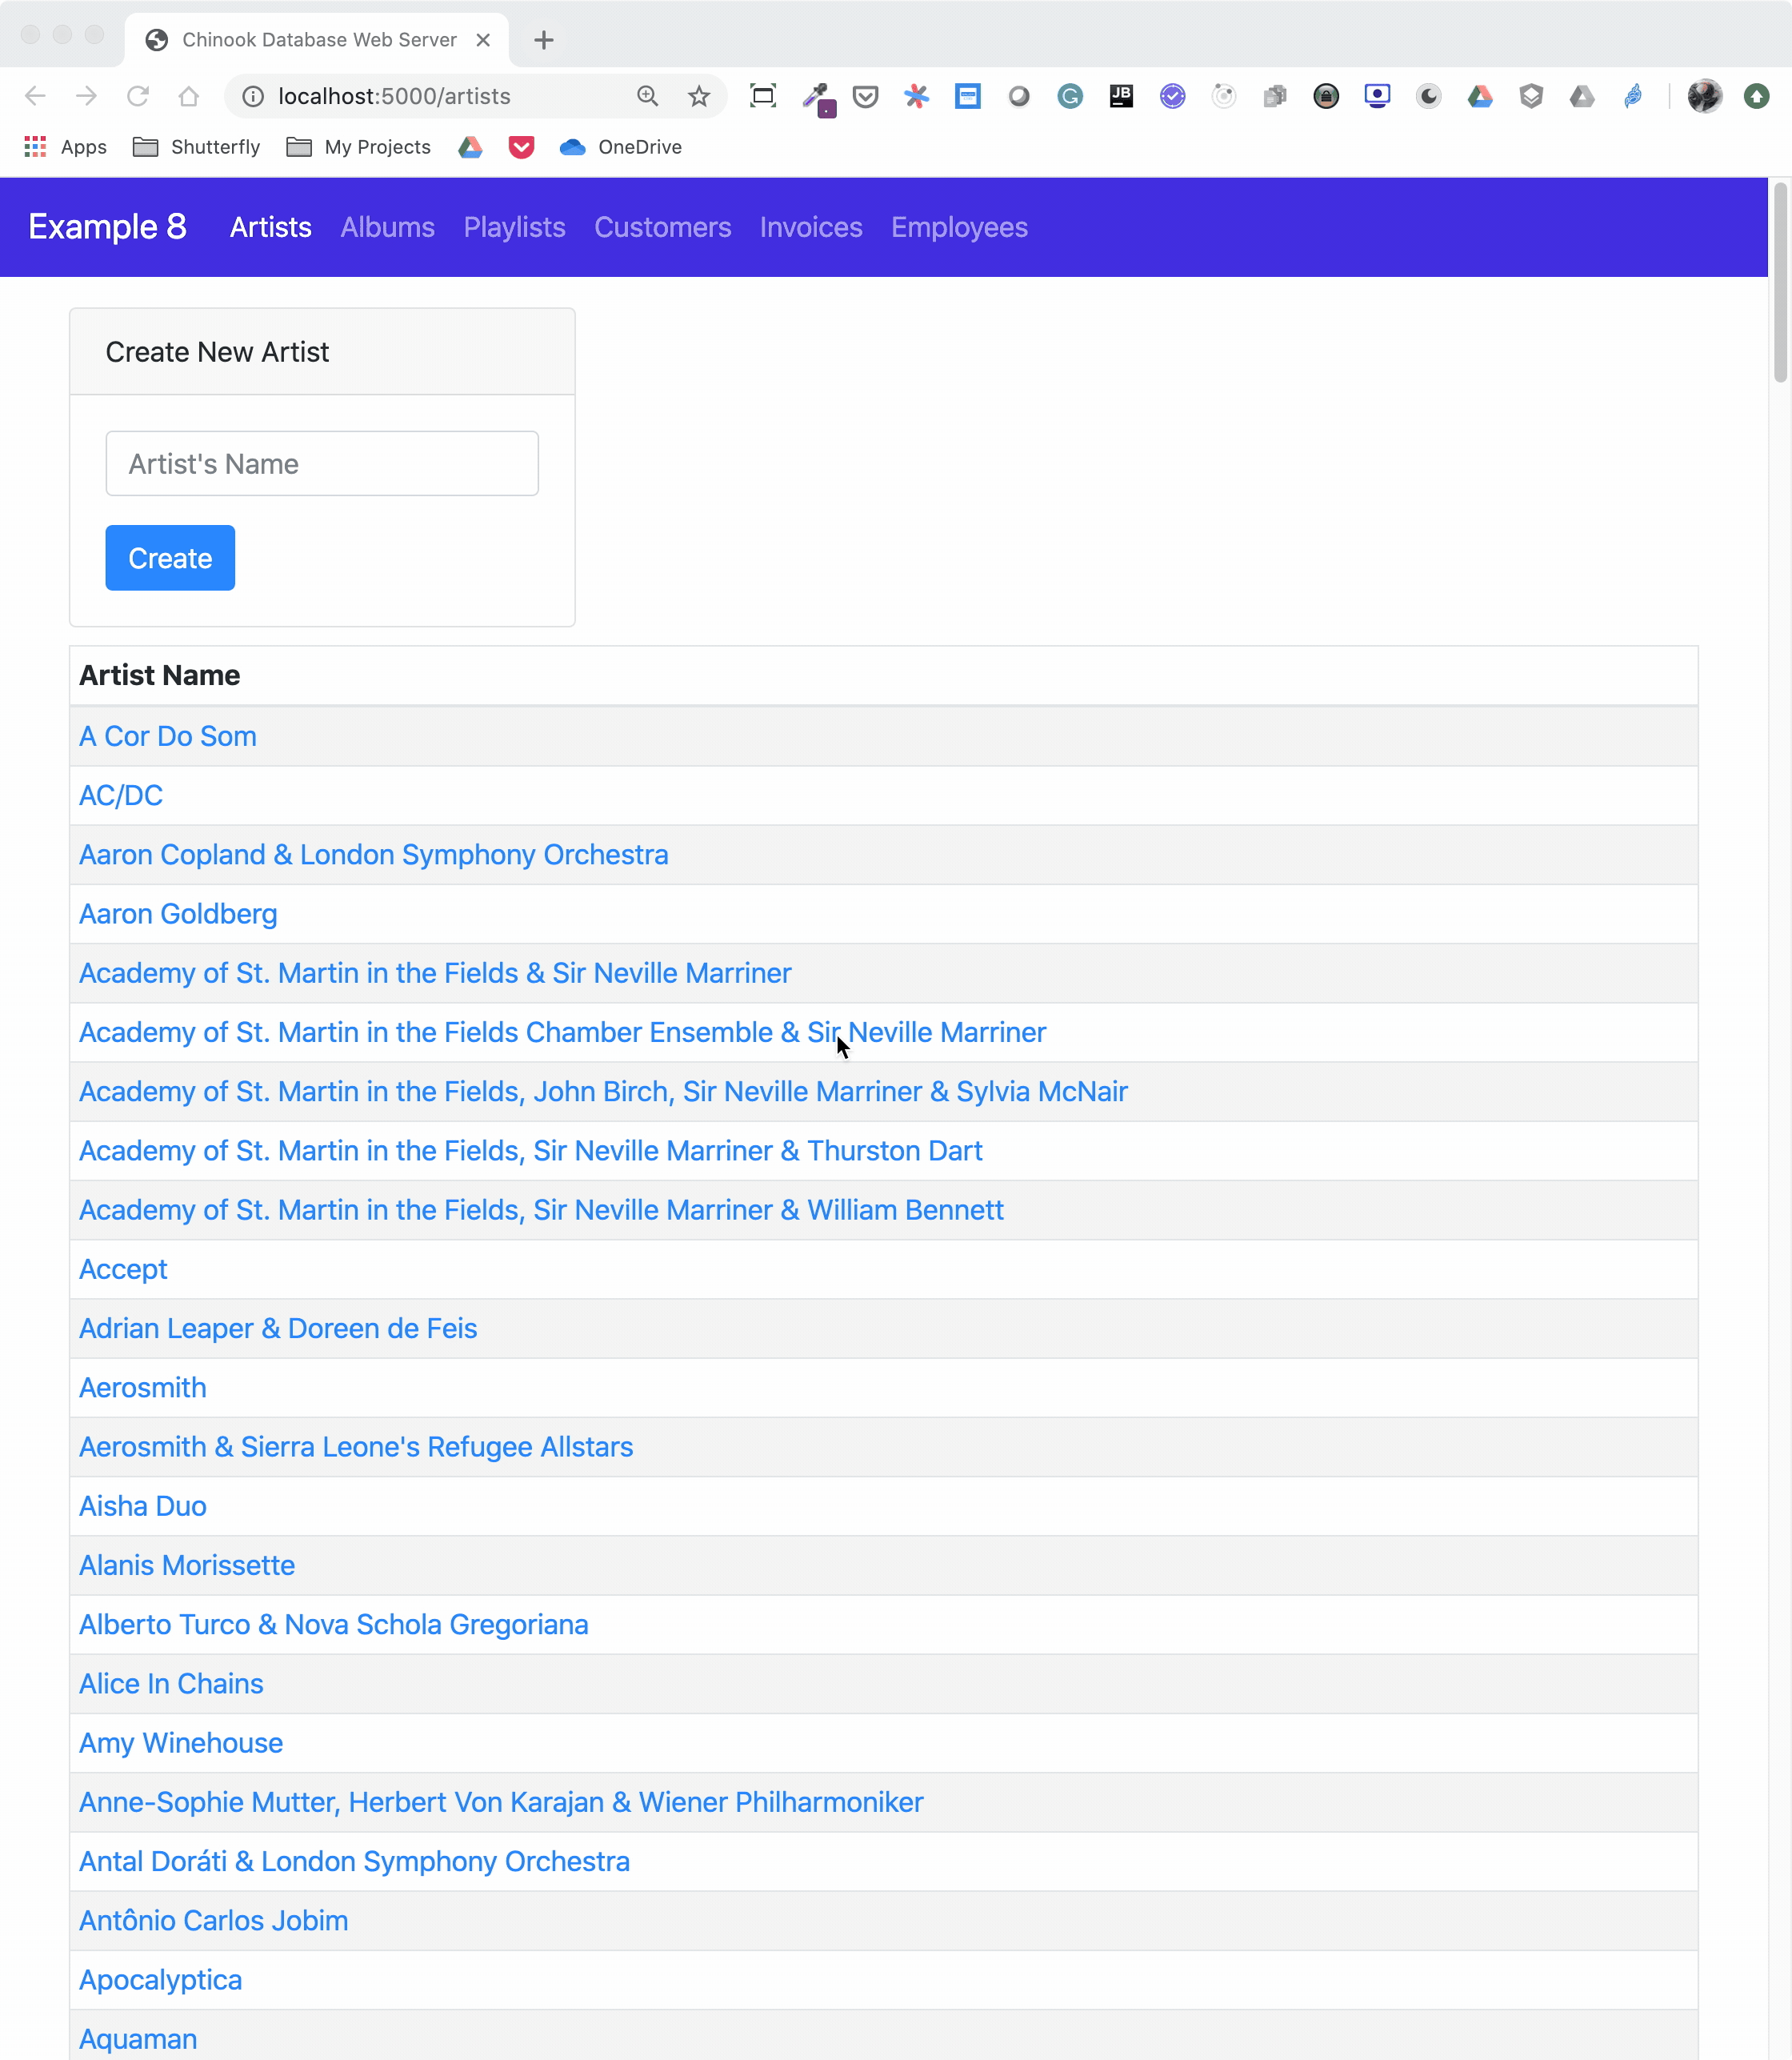
The animated screen capture starts on the application home page, styled using Bootstrap 4. The page displays the artists in the database, sorted in ascending order. The remainder of the screen capture presents the results of clicking on the displayed links or navigating around the application from the top-level menu.
Here’s the Jinja2 HTML template that generates the home page of the application:
1{% extends "base.html" %}
2
3{% block content %}
4<div class="container-fluid">
5 <div class="m-4">
6 <div class="card" style="width: 18rem;">
7 <div class="card-header">Create New Artist</div>
8 <div class="card-body">
9 <form method="POST" action="{{url_for('artists_bp.artists')}}">
10 {{ form.csrf_token }}
11 {{ render_field(form.name, placeholder=form.name.label.text) }}
12 <button type="submit" class="btn btn-primary">Create</button>
13 </form>
14 </div>
15 </div>
16 <table class="table table-striped table-bordered table-hover table-sm">
17 <caption>List of Artists</caption>
18 <thead>
19 <tr>
20 <th>Artist Name</th>
21 </tr>
22 </thead>
23 <tbody>
24 {% for artist in artists %}
25 <tr>
26 <td>
27 <a href="{{url_for('albums_bp.albums', artist_id=artist.artist_id)}}">
28 {{ artist.name }}
29 </a>
30 </td>
31 </tr>
32 {% endfor %}
33 </tbody>
34 </table>
35 </div>
36</div>
37{% endblock %}
Here’s what’s going on in this Jinja2 template code:
- Line 1 uses Jinja2 template inheritance to build this template from the base.html template. The base.html template contains all the HTML5 boilerplate code as well as the Bootstrap navigation bar consistent across all pages of the site.
- Lines 3 to 37 contain the block content of the page, which is incorporated into the Jinja2 macro of the same name in the base.html base template.
- Lines 9 to 13 render the form to create a new artist. This uses the features of Flask-WTF to generate the form.
- Lines 24 to 32 create a for loop that renders the table of artist names.
- Lines 27 to 29 render the artist name as a link to the artist’s album page showing the songs associated with a particular artist.
Here’s the Python route that renders the page:
1from flask import Blueprint, render_template, redirect, url_for
2from flask_wtf import FlaskForm
3from wtforms import StringField
4from wtforms.validators import InputRequired, ValidationError
5from app import db
6from app.models import Artist
7
8# Set up the blueprint
9artists_bp = Blueprint(
10 "artists_bp", __name__, template_folder="templates", static_folder="static"
11)
12
13def does_artist_exist(form, field):
14 artist = (
15 db.session.query(Artist)
16 .filter(Artist.name == field.data)
17 .one_or_none()
18 )
19 if artist is not None:
20 raise ValidationError("Artist already exists", field.data)
21
22class CreateArtistForm(FlaskForm):
23 name = StringField(
24 label="Artist's Name", validators=[InputRequired(), does_artist_exist]
25 )
26
27@artists_bp.route("/")
28@artists_bp.route("/artists", methods=["GET", "POST"])
29def artists():
30 form = CreateArtistForm()
31
32 # Is the form valid?
33 if form.validate_on_submit():
34 # Create new artist
35 artist = Artist(name=form.name.data)
36 db.session.add(artist)
37 db.session.commit()
38 return redirect(url_for("artists_bp.artists"))
39
40 artists = db.session.query(Artist).order_by(Artist.name).all()
41 return render_template("artists.html", artists=artists, form=form,)
Let’s go over what the above code is doing:
- Lines 1 to 6 import all the modules necessary to render the page and initialize forms with data from the database.
- Lines 9 to 11 create the blueprint for the artists page.
- Lines 13 to 20 create a custom validator function for the Flask-WTF forms to make sure a request to create a new artist doesn’t conflict with an already existing artist.
- Lines 22 to 25 create the form class to handle the artist form rendered in the browser and provide validation of the form field inputs.
- Lines 27 to 28 connect two routes to the artists() function they decorate.
- Line 30 creates an instance of the CreateArtistForm() class.
- Line 33 determines if the page was requested through the HTTP methods GET or POST (submit). If it was a POST, then it also validates the fields of the form and informs the user if the fields are invalid.
- Lines 35 to 37 create a new artist object, add it to the SQLAlchemy session, and commit the artist object to the database, persisting it.
- Line 38 redirects back to the artists page, which will be rerendered with the newly created artist.
- Line 40 runs an SQLAlchemy query to get all the artists in the database and sort them by Artist.name.
- Line 41 renders the artists page if the HTTP request method was a GET.
You can see that a great deal of functionality is created by a reasonably small amount of code.

Creating a REST API Server
You can also create a web server providing a REST API. This kind of server offers URL endpoints responding with data, often in JSON format. A server providing REST API endpoints can be used by JavaScript single-page web applications through the use of AJAX HTTP requests.
Flask is an excellent tool for creating REST applications. For a multi-part series of tutorials about using Flask, Connexion, and SQLAlchemy to create REST applications, check out Python REST APIs With Flask, Connexion, and SQLAlchemy.
If you’re a fan of Django and are interested in creating REST APIs, then check out Django Rest Framework – An Introduction and Create a Super Basic REST API with Django Tastypie.
Note: It’s reasonable to ask if SQLite is the right choice as the database backend to a web application. The SQLite website states that SQLite is a good choice for sites that serve around 100,000 hits per day. If your site gets more daily hits, the first thing to say is congratulations!
Beyond that, if you’ve implemented your website with SQLAlchemy, then it’s possible to move the data from SQLite to another database such as MySQL or PostgreSQL. For a comparison of SQLite, MySQL, and PostgreSQL that will help you make decisions about which one will serve your application best, check out Introduction to Python SQL Libraries.
It’s well worth considering SQLite for your Python application, no matter what it is. Using a database gives your application versatility, and it might create surprising opportunities to add additional features.

Conclusion
You’ve covered a lot of ground in this tutorial about databases, SQLite, SQL, and SQLAlchemy! You’ve used these tools to move data contained in flat files to an SQLite database, access the data with SQL and SQLAlchemy, and provide that data through a web server.
In this tutorial, you’ve learned:
- Why an SQLite database can be a compelling alternative to flat-file data storage
- How to normalize data to reduce data redundancy and increase data integrity
- How to use SQLAlchemy to work with databases in an object-oriented manner
- How to build a web application to serve a database to multiple users
Working with databases is a powerful abstraction for working with data that adds significant functionality to your Python programs and allows you to ask interesting questions of your data.
You can get all of the code and data you saw in this tutorial at the link below:
Download the sample code: Click here to get the code you’ll use to learn about data management with SQLite and SQLAlchemy in this tutorial.

Further Reading
This tutorial is an introduction to using databases, SQL, and SQLAlchemy, but there’s much more to learn about these subjects. These are powerful, sophisticated tools that no single tutorial can cover adequately. Here are some resources for additional information to expand your skills:
- If your application will expose the database to users, then avoiding SQL injection attacks is an important skill. For more information, check out Preventing SQL Injection Attacks With Python.
- Providing web access to a database is common in web-based single-page applications. To learn how, check out Python REST APIs With Flask, Connexion, and SQLAlchemy – Part 2.
- Preparing for data engineering job interviews gives you a leg up in your career. To get started, check out Data Engineer Interview Questions With Python.
- Migrating data and being able to roll back using Flask with Postgres and SQLAlchemy is an integral part of the Software Development Life Cycle (SDLC). You can learn more about it by checking out Flask by Example – Setting up Postgres, SQLAlchemy, and Alembic.

