Rekurzija in ŽG - Lindenmayer

Well, it’s Plain English rather than Python (but easily translated) and it’s exactly ten lines (rather than less than ten), but I think this little Lindenmayer interpreter…
To interpret some times:
If the times are 0, exit.
Put "A+FA-FA-F++" into a string.
Loop. If the string is blank, break.
Get a letter from the string.
If the letter is "-", turn right 1/4 of the way around; repeat.
If the letter is "+", turn left 1/4 of the way around; repeat.
If the letter is "A", interpret the times minus 1; repeat.
If the letter is "F", draw a line 1/8 inch long; repeat.
Repeat.
…is interesting because small changes produce such significantly different results. With the code shown above, for example, the output looks like this:
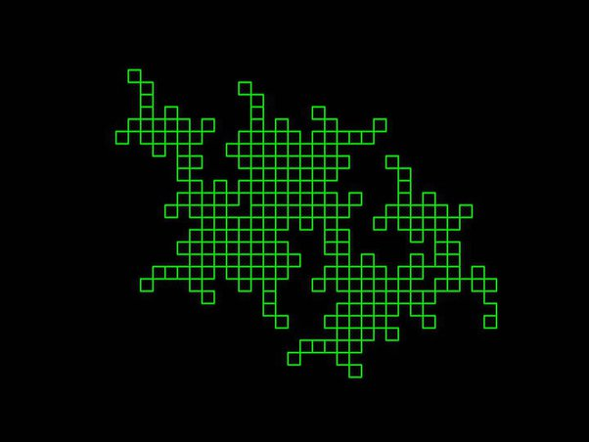
But if we turn 1/3 of the way around (instead of 1/4) we get this:
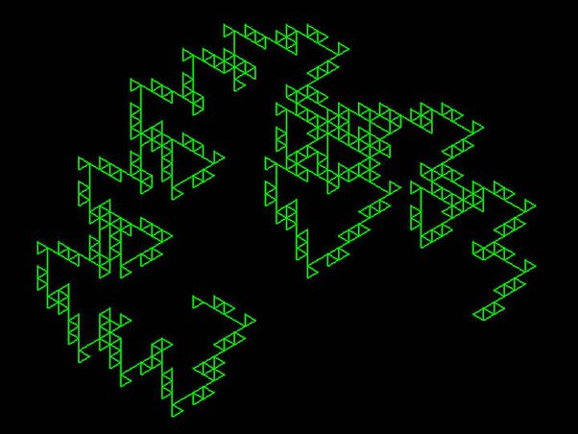
And if we turn 1/6 of way around, we get:
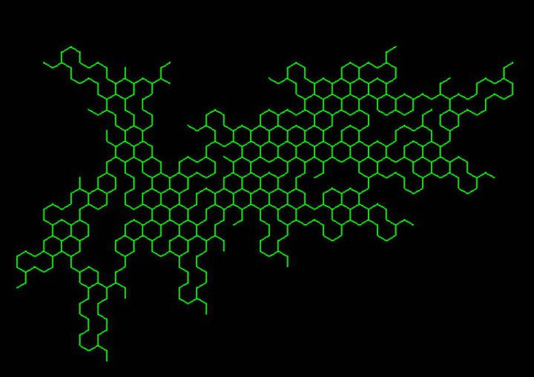
And if we go back to 1/4 turns and change the characters in the string to something like this…
Put "FA+FA-FA-FAFA+FA+FA-FA++" into a string.
…we get a significantly different result, like this:
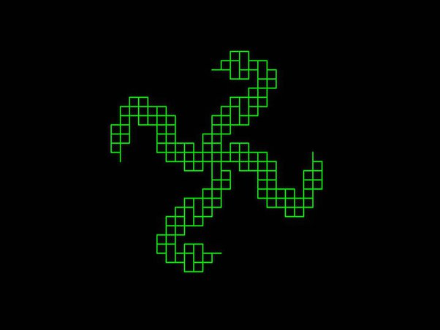
And we can get a brain-like pattern if we use that same string with 1/8 turns:
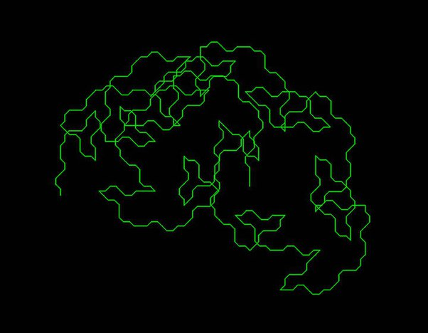
Fun stuff. I could play with it all day. And if you allow yourself just a few more characters and lines, you can grow bushes like these…
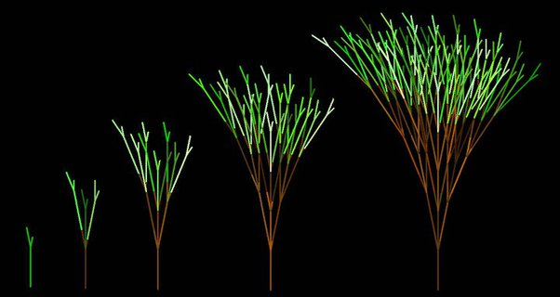
…and curious curves like this…
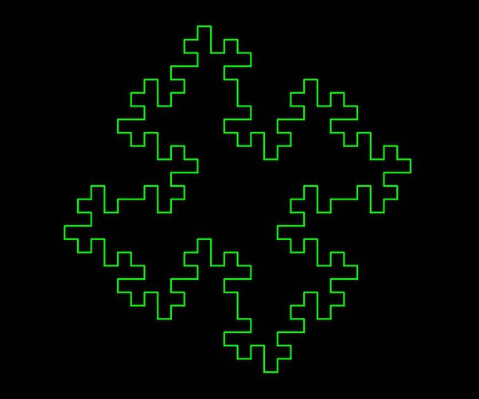
…and this:
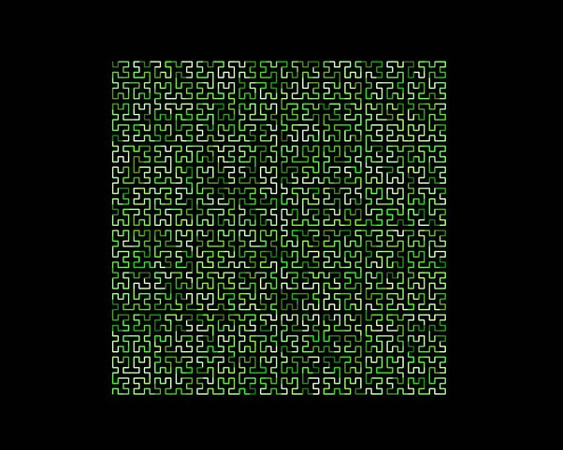
Et voila!

